User Guide 6 Managing Planning Permits in SPEAR
Purpose of this User Guide
The purpose of this User Guide is to provide assistance to Responsible Authority users about how to issue and manage planning permit decisions in SPEAR.
Who should read this?
Primary audience: Responsible Authorities
For information: Applicant Contacts and referral authorities
Introduction
Issuing a planning permit decision in SPEAR is similar to making a planning permit decision for a paper application. The main difference is that instead of sending a copy of the planning permit or refusal or notice of decision to grant a permit to relevant stakeholders via the post or email, the Responsible Authority adds the permit decision as a PDF document to SPEAR and authenticates it.
Any objectors, who lodge an objection to the application in SPEAR, will also be notified by email of the Responsible Authority’s decision.
6.1 How does a Responsible Authority issue a planning permit decision in SPEAR?
To issue a planning permit decision, prepare the document (whether it be a permit, Notice of Decision (NOD) or refusal) using your usual process (i.e. via the Responsible Authority planning software) and save it as a PDF document. There is no need to print and sign.
In SPEAR, the Responsible Authority can make a planning permit decision once an application has reached the status, ‘Permit Decision Pending’. This indicates that all responses to referral requests under the Planning and Environment Act have been completed (or have been overridden by the Responsible Authority) and the Applicant Contact has fully responded to any requests for further information. To make the decision, the Responsible Authority selects the ‘Make Decision - Planning Permit’ mandatory action.

The Responsible Authority can select from one of the following four options:
- ‘Grant Permit’
- ‘Issue Notice of Decision to grant a Permit’ (NOD)
- ‘Refuse Permit’ or
- ‘Permit not required’
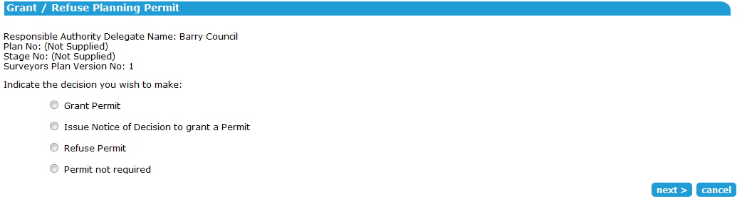

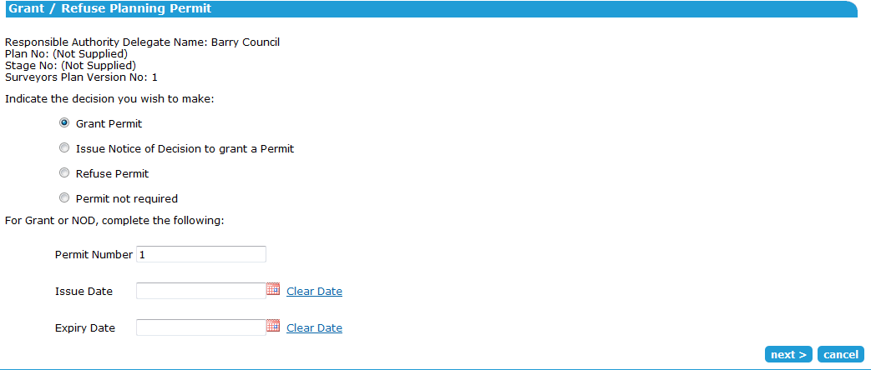
Selecting the ‘Grant Permit’ option expands the screen to collect additional information, including the permit number, permit issue date and permit expiry date.
NOTE: The permit number will be pre-populated with the planning permit reference number (as defined by the Responsible Authority); this can be overwritten if it is not correct.

Selecting the ‘Issue Notice of Decision to grant a Permit’ requires the user to enter the planning permit number and the issue date.
NOTE: The permit number will be pre-populated with the planning permit reference number (as defined by the Responsible Authority); this can be overwritten if it is not correct.
Selecting the ‘Refuse Permit’ option requires the user to supply the issue date:
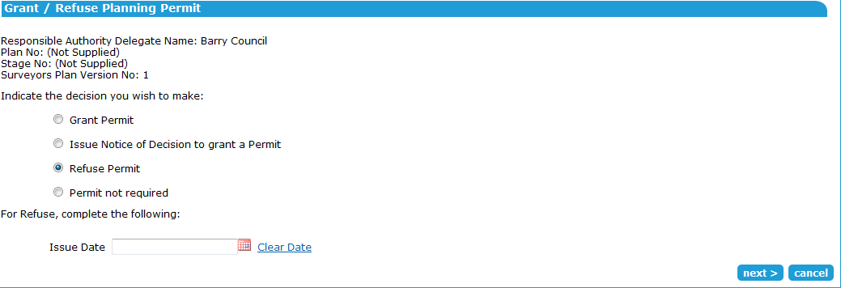

Whether the user selects ‘Grant’, ‘NOD’ or ‘Refuse’, the system will prompt you to attach a decision document as below. Select the permit decision document and click ‘add now’.
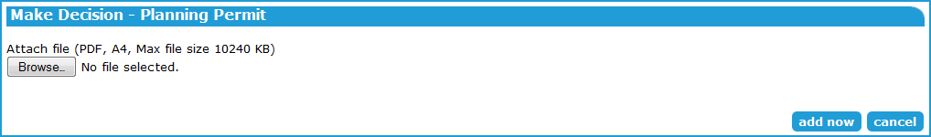
Select any option and clicking ‘next’ takes you to the Attach File (PDF) screen.

The system will display a confirmation, and direct you to the Endorse Plans/Reports screen. You can select documents to endorse now, elect to endorse documents later or that no endorsement is required. Depending on the option selected, you will be presented with an unauthenticated planning permit decision and either documents to be endorsed or a mandatory action to ‘Endorse Plans/Reports’.
If selecting ‘Permit not required’, you will be given the opportunity to attach a PDF document or enter the reason.
The decision document/s require authentication, before notifying all relevant parties that the decision has been made.

If the user has chosen to issue a Notice of Decision, a new mandatory action will appear to ‘Prepare Decision to Grant Enquiry’ form. See User Guide 47 for details on completing this action.
6.2 How does the Responsible Authority endorse documents?
The Responsible Authority will be prompted to make the endorsement decision once the planning permit has been added. If choosing to endorse now, the documents to be endorsed can be selected and the endorsement decision authenticated.
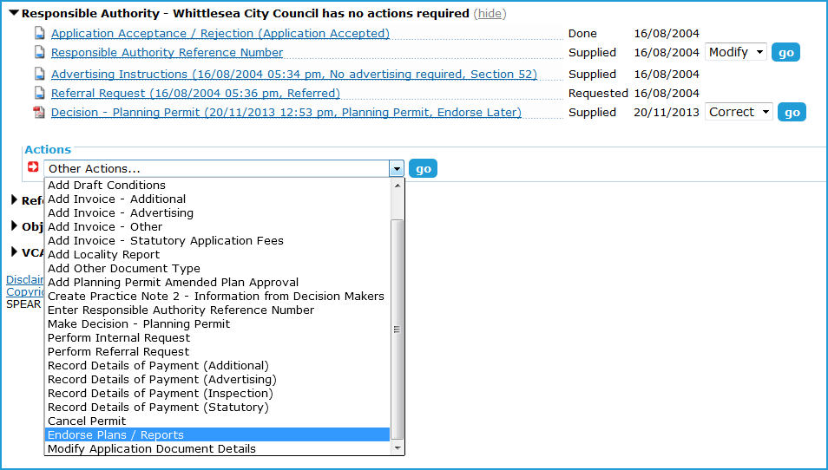
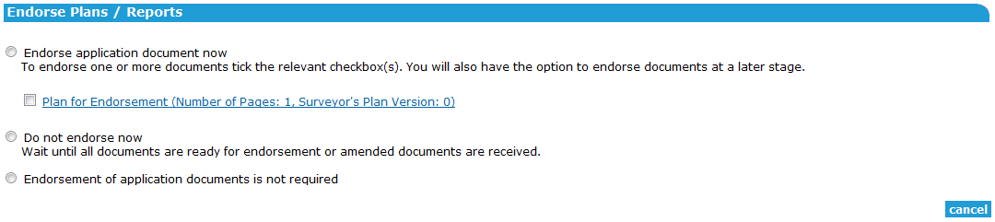
The Endorse Plans / Reports screen also allows the Responsible Authority to indicate that endorsement is not required, or to endorse later after amended documents have been received (i.e. if there are conditions on the permit which require revised plans to be submitted prior to them being endorsed). This can be done using the ‘Endorse Plans / Reports’ optional action.

The Responsible Authority is also able to attach ‘Other Document Type’ as an endorsable document. This allows the Responsible Authority to endorse something they have received outside of SPEAR. These documents can be selected and endorsed during the regular endorsement process and can be modified by the Responsible Authority at any time.
SPEAR applies a watermark to all documents that have been endorsed. The watermark shows the date of endorsement, together with the endorsing officers name, planning permit number, council name, and page number.
NOTE: The system numbers each page as part of the total page count of all documents selected for endorsement, i.e. if three documents are selected for endorsement, and each document includes 3 pages, then numbering will run ‘1 of 9’ through ‘9 of 9’.
An Applicant Contact can submit new documents to SPEAR or modify existing documents at any time. When this occurs, the Responsible Authority is given a mandatory action to ‘Assess Proposed Changes to Application’.
See User Guide 7 for information on processing amendment requests. The same endorsement process is undertaken for amended documents.
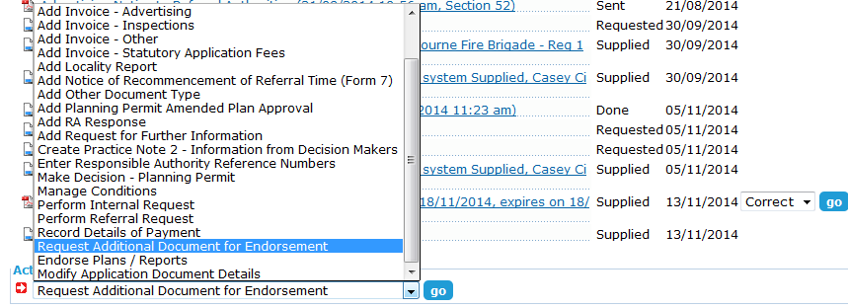
The Responsible Authority can request additional documents for endorsement. This can occur at any time, before or after documents have been endorsed. To do this, select ‘Request additional document for endorsement’ from the ‘other actions’ list.

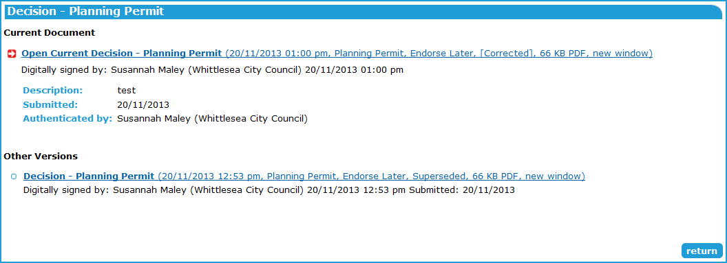
6.3 How do I correct a planning permit?
The Responsible Authority can correct the most current planning permit decision (either ‘Granted’ or ‘NOD’) pursuant to Section 71 of the Planning and Environment Act, by selecting the action to ‘correct’ the document. Click ‘go’ to continue.
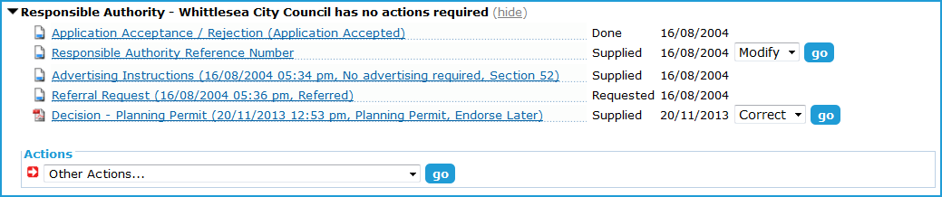
The user will be prompted to attach a corrected decision document, correct relevant dates (if required) and add a brief description of the correction. Once completed click ‘add now’, authenticate the document, and SPEAR will notify relevant parties of the correction.
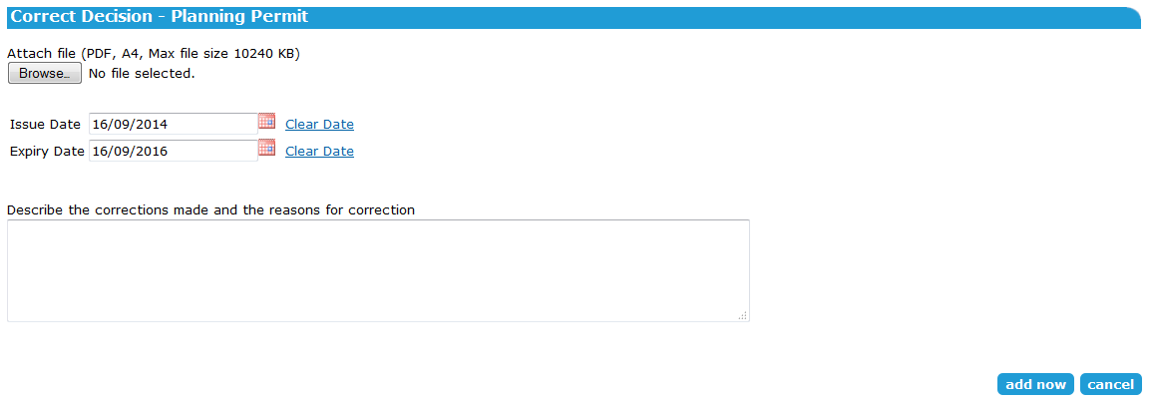

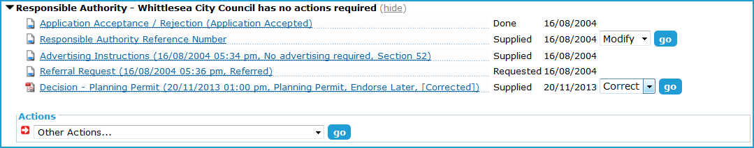
The system will indicate the correction in the permit decision description line on the Details screen.
The previous permit will be watermarked as ‘superseded’ and stored as a previous version.
6.4 How do I change a planning permit decision?
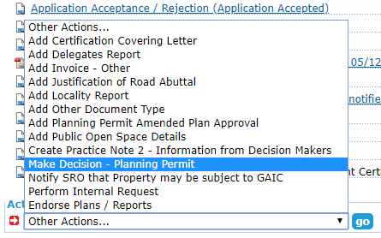
For a planning permit only application, after a permit decision has been made, the application remains active for 60 days before moving to the completed list.

If a permit decision is required to be changed before the 60 day timeframe, this can be completed by using the ‘Make Decision – Planning Permit’ action accessed via the ‘Other actions…’ menu.
The steps for making the permit decision are the same as shown above.
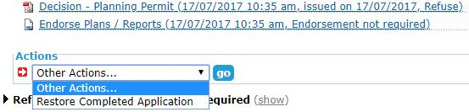
For a planning permit only application, if a new planning permit decision needs to be made after the 60 day timeframe, the application will first need to be restored.

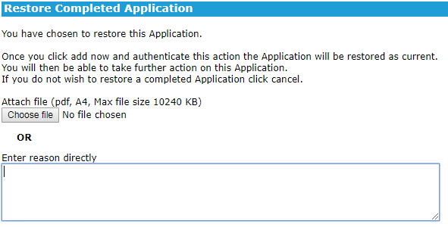
After restoring you will be required to provide a reason by either attaching a PDF or typing a reason directly into SPEAR, then authenticating the action.

After authenticating, the application status will not change, but the ‘Other actions…’ menu will be populated with more options, including the ‘Make Decision – Planning Permit’ action. For joint planning permit & certification applications, the ‘Make Decision – Planning Permit’ option will remain available from the ‘Other actions…’ menu until the application is completed.
6.5 How do I expire a planning permit application?
If further documents or plans for endorsement are requested after the planning permit is granted and these are not provided by the time the permit expires, the application will not automatically expire and will remain in the Responsible Authority’s ‘current’ list. The Responsible Authority can elect to expire the permit application to move it to their ‘completed’ list.
Select ‘Expire Permit Application’ from the ‘Other Actions’ drop-down list and click ‘go’. You must attach or enter a reason for the decision to expire and authenticate this action.
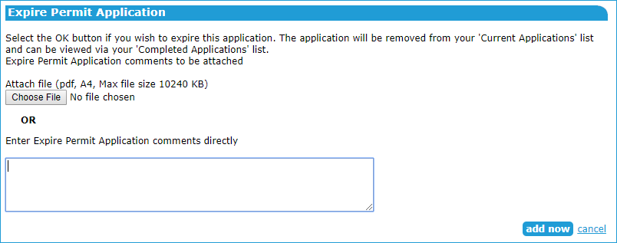
Note: this function is available for ‘planning permit only’ applications. A joint permit and certification application can’t be expired in this way.
If you have expired a planning permit application, you can use the ‘Restore completed application’ function to return it to the ‘current’ list
Need more information?
Further information on this topic can be found by:
- Visiting the SPEAR website www.spear.land.vic.gov.au/SPEAR.
- Contacting the SPEAR Service Desk on 9194 0612 or email spear.info@delwp.vic.gov.au
- Selecting the Help link in the relevant area of the system.

